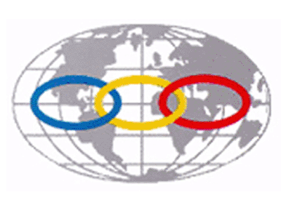
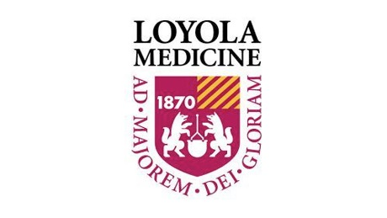
Seminal Contributions in the Management of Thrombotic and Cardiovascular Diseases
3:30 – 5:00pm
CTRE Room #504, Loyola University, Health Sciences Division

3:30pm – 3:45pm Introduction and welcome
Margaret Callahan, CRNA, PhD, FNAP, FAAN
Jawed Fareed, PhD, FAHA

3:45pm – 4:00pm Advances in the Management of Venous Disorders. Impact of Dr. Russell Hull’s Contributions.
Peter Bacher, MD, PhD

4:00pm – 4:15pm Vascular Diseases – Dr. Ray Dieter III, Dr. Ray Dieter Jr. and Dr. Robert Dieter’s Efforts in Providing Dedicated Books and their Educational Impact.
Jawed Fareed, PhD, FAHA

4:15pm – 4:30pm Stroke and Other Neurovascular Disease. Dr. Jose Biller’s Contributions.
Camilo Gomez, MD, MBA

4:30pm – 4:45pm Thrombosis Awareness. The unparalleled Contributions of Dr. Goldhaber.
Jeanine Walenga, PhD / John Fanikos, PharmD

4:45pm – 5:00pm Georgia Thrombosis Forum. An Exemplary for Innovative Approaches in Enhancing the Thrombosis Awareness. The Vision of Dr. Laddu.
Jawed Fareed, PhD, FAHA

This recognition program is organized under the auspices of the International Union of Angiology to recognize the outstanding contributions of Dr. Hull, Dr.’s Dieter, Dieter and Dieter, Dr. Biller and Dr. Goldhaber, all of whom have contributed significantly in educational programs and enhancing the awareness of vascular diseases at various levels.

